The Mixed Nuts
Set C Last revised on 2016.03.06

C01-Fine And Dandy(KVF).2016.01.30.pdf
C01-Fine And Dandy(KVM).2016.01.30.pdf
C02-I'm Forever Blowing Bubbles(KVD).2016.01.30.pdf
C03-Girl (Boy) From Ipanema(KVF).2014.01.19.pdf
C03-Girl (Boy) From Ipanema(KVM).2014.01.19.pdf
C04-It's D'Lovely(KVF).2015.03.03.pdf
C04-It's D'Lovely(KVM).2015.03.03.pdf
C05-All Of Me(KVF).pdf
C05-All Of Me(KVM).pdf
C06-Autumn Leaves(KVF).2015.01.01.pdf
C06-Autumn Leaves(KVM).2015.01.01.pdf
C07-Let's Twist Again(KVF).2016.03.06.pdf
C07-Let's Twist Again(KVM).2016.03.06.pdf
C08-Don't Get Around Much Anymore(KVF).2015.01.01.pdf
C08-Don't Get Around Much Anymore(KVM).2015.09.13.pdf
C09-Come Fly With Me(KVF).pdf
C09-Come Fly With Me(KVM).pdf
C10-They Can't Take That Away From Me(KVF).2015.01.01.pdf
C10-They Can't Take That Away From Me(KVM).2015.01.01.pdf
C11-My Way(KV). 2015.03.09.pdf
C12-There Is A Tavern In The Town(K).pdf
C13-Sugar Blues(K).pdf
C14-I Can't Give You Anything But Love(KV).2014.03.07.pdf
C15-Fly Me To The Moon(KVF).2015.02.08.pdf
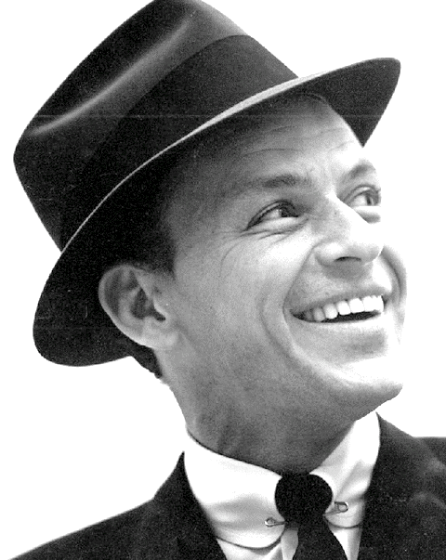
C15-Fly Me To The Moon(KVM).2015.02.08.pdf
C16-All Or Nothing At All(KVF).2014.10.03.pdf
C16-All Or Nothing At All(KVM).2014.10.03.pdf
C17-Chattanooga Choo Choo(KVF).2014.08.17.pdf
C17-Chattanooga Choo Choo(KVM).pdf

